
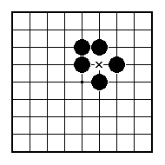
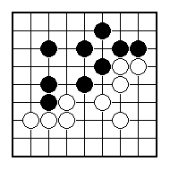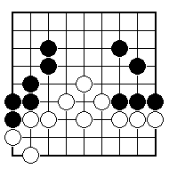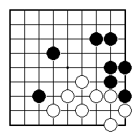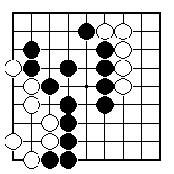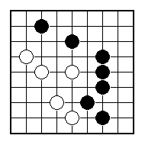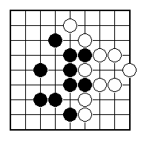
Where should Black play to defend the most territory?

Where should Black play to defend the territory at the top?

Whereabouts should Black play defensively?

Whereabouts should Black play next?
.

Whereabouts should Black play next?

Whereabouts does Black need to play next?

NAME:
BRITISH GO ASSOCIATION CERTIFICATE LEVEL 3 - SHEET 6

KEEPING YOUR TERRITORY

